BS6202 Assignment 3

Yaoding Chen | 15 Aug 2021

Task 1
Gestalt is the interplay between the parts and the whole. Kurt Koffka, one of the founding fathers of Gestalt psychology, made a statement about this. He said, “The whole is ‘other’ than the sum of its parts.” This phrase has been translated to the familiar saying, ‘the whole is greater than the sum of its parts’. (e.g. do you see a triangle in the below image) Koffka insisted that the emergent entity is ‘other’ (not greater or lesser) than the sum of the parts. Based on what you understand about Gestalt, what do you think? (Write an one-page reflection)

Gestalt principles are the principles of human perception, which depicts human tendency to assemble smaller, individual items into a unified whole. Shortly speaking, in Gestalt phycology, the whole is greater than the sum of its parts (Wong, 2010). There are a few principles proposed by Gestalt phycologists. I will give an example for each principle as follows.
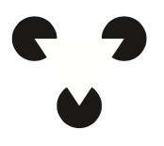
- Simplicity
Our brain tends to consider different individual items as an organized entity so as to create simplicity. For example, although the above figure is merely formed by three pac men, yet we tend to believe that there is a triangle in between when we first look at the figure, thus ignoring the three individual pac men that forms the figure. Our brain tends to first recognise the overall shape.

- Figure-ground
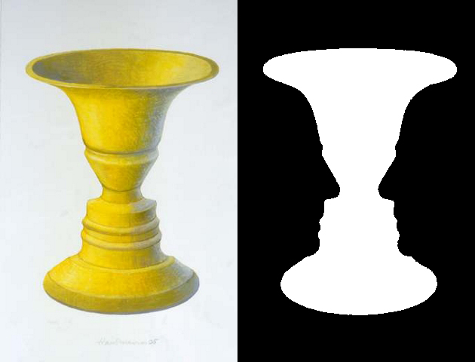
When we look at an item, we tend to do a classification between background and foreground. A classic example is Rubin’s vase, where people could recognise different background and hence observe different articles. In this way, one may find a designed work contain dual information with even the same shape.

- Proximity
The principle of proximity refers to a tendency where people tend to recognise separate items close to each other as a whole entity. For example, the below figure shows how sperate lines organised close to each other forms a deer-like shape.

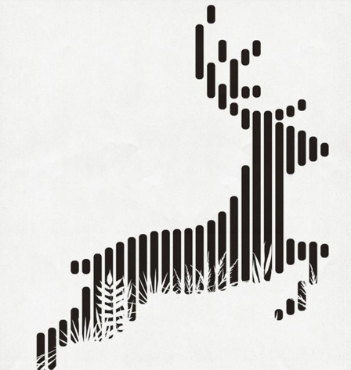

- Similarity
Our brain does not only do background-foreground classification , it also clusters what we see according to their similarity. Like in the figure below, we tend to look at the circles with the same colour to see whether they form any special shape.

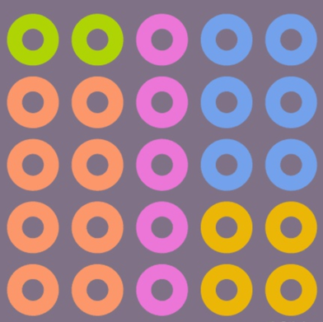

- Common fate
Our brain tend to identify moving items as an entity. For example, we tend to believe the crowd of birds flying to the same direction as a larger bird.

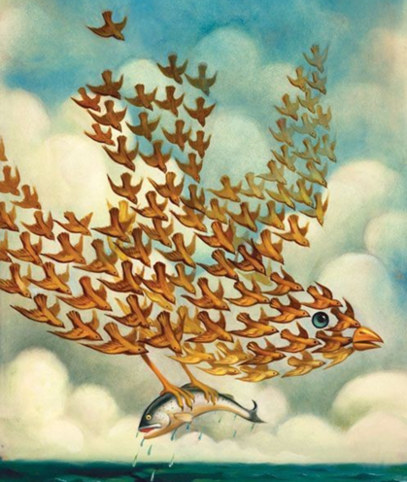
- Symmetry
Two symmetric item could be considered a single item for our brain. For example, in the below figure, although bike tires and well cover are quite different but their symmetric shape forms a sense of unity for audience.

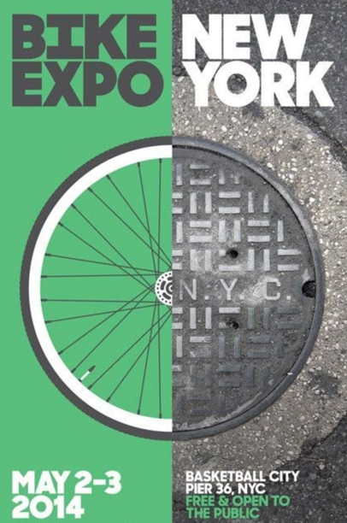

- Symmetry
Similarly, items aligning in parallel are considered united, as is shown in the below figure.

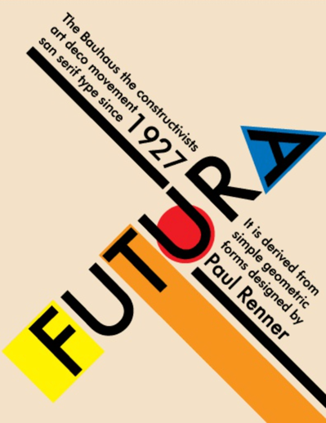

- Good continuation
Good continuation of an individual item could attract us to identify the overall shape of the continuum.


- Closure
We tend to add closure, i.e. imagine a closed silhouette to an individual item even if they are not closed, like in the below illustration of a zebra which is not depict in closed lines surrounding it.

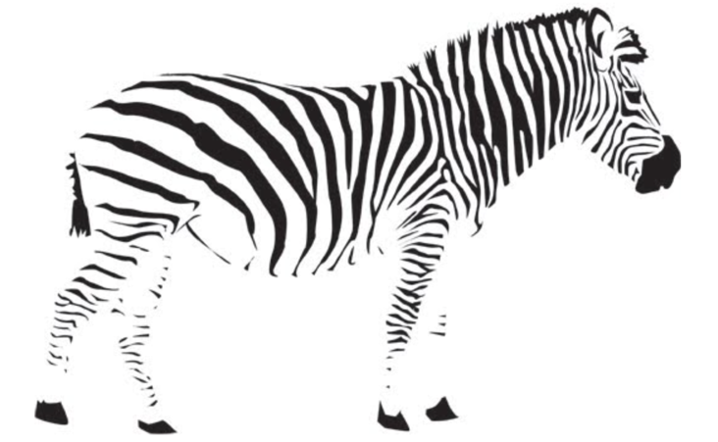

- Common region
The principle of common region reflects our tendency to identify some chosen or connected items as the same group, even though they might be a bit different
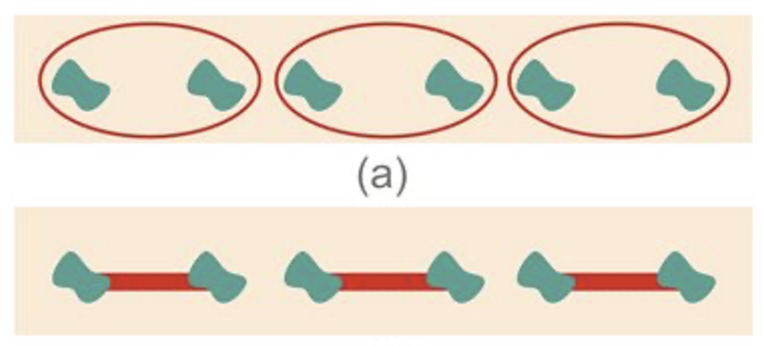

Photo credits: most graphs are taken from https://zhuanlan.zhihu.com/p/36991992 except the last one from Dejan Todorovic (2008) Gestalt principles. Scholarpedia, 3(12):5345.

Task 2:
Find a graph from a publication (of reasonable complexity). Assess based on gestalt’s principles whether the graph is effective. Propose (and maybe redraw a simplified version to illustrate your idea) how it can be made effective.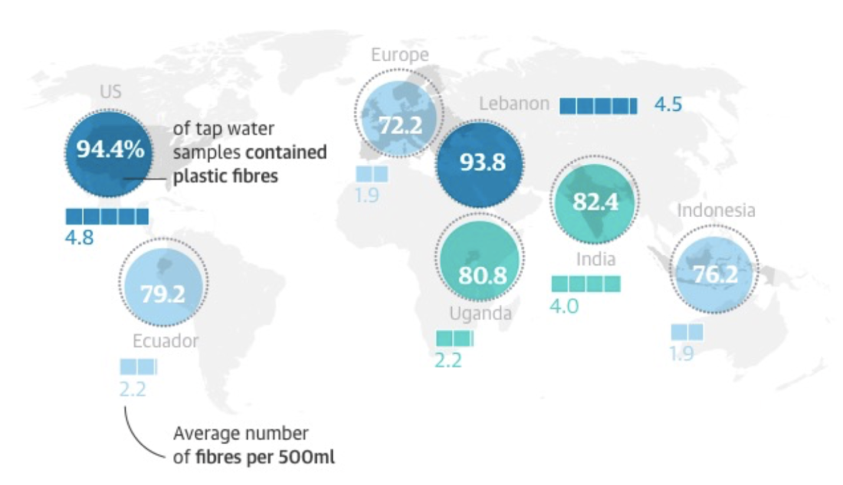
The above figure is taken from Carrington (2017) on The Guardian. It aims to show how widespread microplastics is around the globe. The graph contains a lot of information, i.e. % of tap water samples contained plastic fibres and average number of fibres per 500mL for different regions around the world.

Assessment: The graph does not assign different colours to different countries, but still makes a clear division of data across countries, thanks to successful application of the principle of similarity and proximity (colour and shape similarity + physical proximity to coloured items), where each data label are grouped when we look at them. It also tries to use the principle of closure to give each circle an almost-closed circle, which indicate high proportion of water contaminated by plastics. The division of background and foreground is clear, thanks to different colour choices, which is a good application of figure-ground principle. Overall, the figure is nicely and neatly drawn and effictively delivery its information to audience from different classes.

Proposed improvement: However, there are still a few things that this graph can improve. First of all, the circles, though creative, look too similar, which may not be a good representation of different data and it is a bit misleading to make different data look the same. I think a pie chart can better illustrate the data, which is also good for comparison. Second, the bar chart of Lebanon data is too far from the circle, which may create misunderstanding of the part of the figure due to potential violation of the principle of proximity. Furthermore, an interactive map which allows the audience to click the country of their interest to see more detail could be a better choice in the future.

References
Carrington, D. (2017, September 6). Plastic fibres found in tap water around the world, study reveals. The Guardian. https://www.theguardian.com/environment/2017/sep/06/plastic-fibres-found-tap-water-around-world-study-reveals
Wong, B. (2010). Gestalt principles. Nature Methods, 7(12), 941. https://doi.org/10.1038/nmeth1210-941

